**TITLE : SMART WATER MANAGEMENT**

**PHASE 5 : Project Documentation & Submission**

**Smart water management involves using technology to optimize the use and distribution of water resources. Here are some innovative approaches and technologies**:

1. **IoT Sensors :** Installing sensors in water supply systems to monitor water quality, flow rates, and leaks in real-time, allowing for quick response and efficient water distribution.

2. **Predictive Analytics:** Using data analytics and machine learning to predict water demand, identify leakages, and optimize water distribution, helping to reduce wastage.

3. **Smart Meters:** Implementing smart water meters that provide real-time consumption data to both consumers and utilities, promoting water conservation and efficient billing.

4. **Water Recycling**: Advanced water treatment technologies to recycle and reuse wastewater, reducing the strain on freshwater sources.

5. **Remote Monitoring**: Using remote monitoring systems and mobile apps to allow consumers to track their water usage and make informed decisions about conservation.

6. **AI-driven Leak Detection:** Utilizing artificial intelligence to detect leaks in pipelines and infrastructure, preventing water loss.

7. **Blockchain for Transparency:** Implementing blockchain technology for transparent and secure management of water transactions and data sharing among stakeholders.

8. **Water Quality Sensors**: Deploying sensors to continuously monitor water quality, ensuring safe and clean water supply.

9. **Cloud-Based Management**: Cloud-based platforms for data storage and analysis, facilitating collaboration among water utilities and stakeholders.

10. **Green Infrastructure:** Incorporating green infrastructure such as permeable pavements and rain gardens to manage stormwater and improve water quality. These innovations aim to enhance the efficiency, sustainability, and reliability of water management systems while addressing the growing challenges of water scarcity and environmental conservation.

**1. Sensors and Data Acquisition:**

* **Water Quality Sensors:** pH sensors, turbidity sensors, dissolved oxygen sensors, and chemical sensors.
* **Flow Sensors:** Ultrasonic or electromagnetic flow sensors to measure the flow rate.
* **Level Indicators:** Ultrasonic or pressure-based sensors to measure water levels.
* **Microcontroller:** Arduino or Raspberry Pi for data processing and sensor interfacing.

**Water Quality Sensors:**

**Turbidity sensors:**

A turbidity sensor is an analytical sensor that measures turbidity. They are highly useful and effective instruments to identify the clarity and particle content in a solution, like water. Turbidity sensors are used to reduce waste, improve yields, and analyze water quality in a wide range of industries.

**Temperature sensors:**

Temperature sensors help to monitor water mixing, which is important in reservoirs, lakes, and other water systems. Temperature changes indicate changes in the distribution of water, which can be a sign of pollution, contamination, or other issues.

**Flow sensors:**

**Ultrasonic distance sensor:**

As they utilize high-frequency (ultrasonic) soundwaves to calculate the distance to a remote object without physically touching it, they can be used to create systems that reliably determine wave height and water levels at much lower installation and maintenance costs.

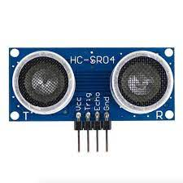

**2. Communication:**

* **Wireless Communication:** GSM, Wi-Fi, or LoRa modules for transmitting data to the central server.
* **Protocols:** MQTT or HTTP for secure data transmission.

**Wifi module:**

Through the Wi-Fi system, the sensor output data is sent to the concerned authority for further steps to supervise the water leakage. These sensor values are continuously uploaded into the cloud using wifi module.

**3. Centralized Server:**

* **Database:** MySQL or MongoDB to store real-time and historical data.
* **Backend:** Node.js, Django, or Flask for server-side scripting.
* **Data Analytics:** Python libraries like Pandas and Matplotlib for data analysis and visualization.
* **Web/Mobile Application:** HTML, CSS, JavaScript for the user interface. Charting libraries like Chart.js for graphical representation of data.

**4. User Interface:**

* **Web Application:** Allows authorities to monitor data, set thresholds, and receive alerts.
* **Mobile Application:** Provides real-time data access and alerts for consumers.

**5. Power Supply:**

* **Solar Panels:** To provide sustainable power to remote monitoring stations.
* **Battery Backup:** Lithium-ion batteries for continuous operation during power outages.

**6. Security:**

* **Data Encryption:** Use SSL/TLS protocols for secure data transmission.
* **Authentication:** Implement strong authentication mechanisms to prevent unauthorized access.

**7. Maintenance:**

* **Remote Diagnostics:** Include features for remote diagnosis and troubleshooting.
* **Regular Updates:** Ensure software and firmware updates for system efficiency and security.

By implementing this Smart Water Monitoring System, communities can make informed decisions about water usage, reduce waste, and ensure a sustainable and safe water supply for everyone.

**DESIGN**

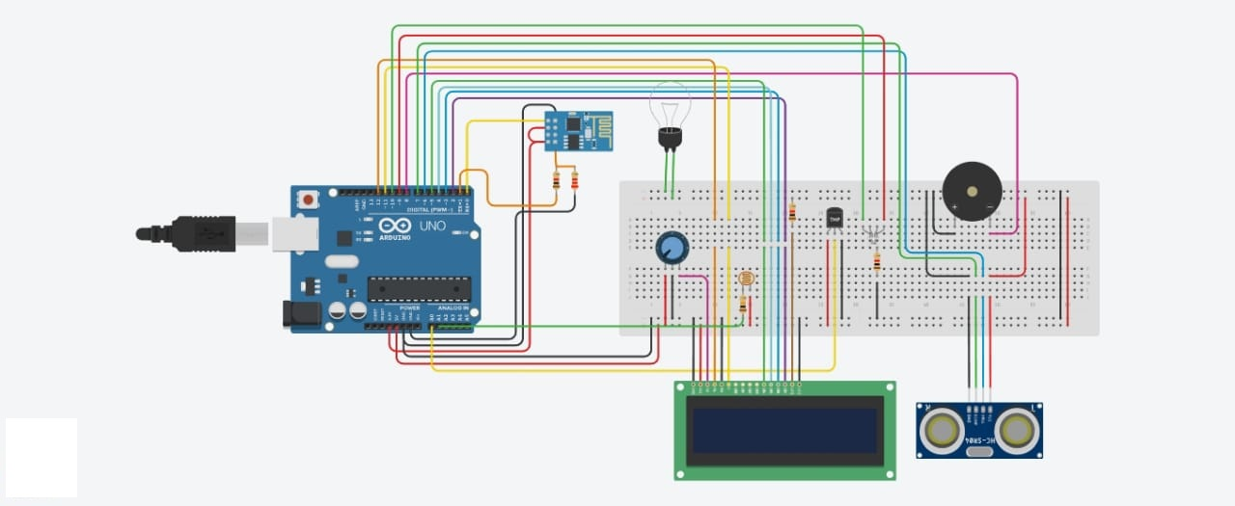

[In this part you will continue building your project.

* Continue building the project by developing the data-sharing platform.
* Use web development technologies (e.g., HTML, CSS, JavaScript) to create a platform that displays real-time water consumption data.
* Design the platform to receive and display water consumption data from IoT sensors and promote water conservation efforts. ]

**Water Consumption platform (Website design)**

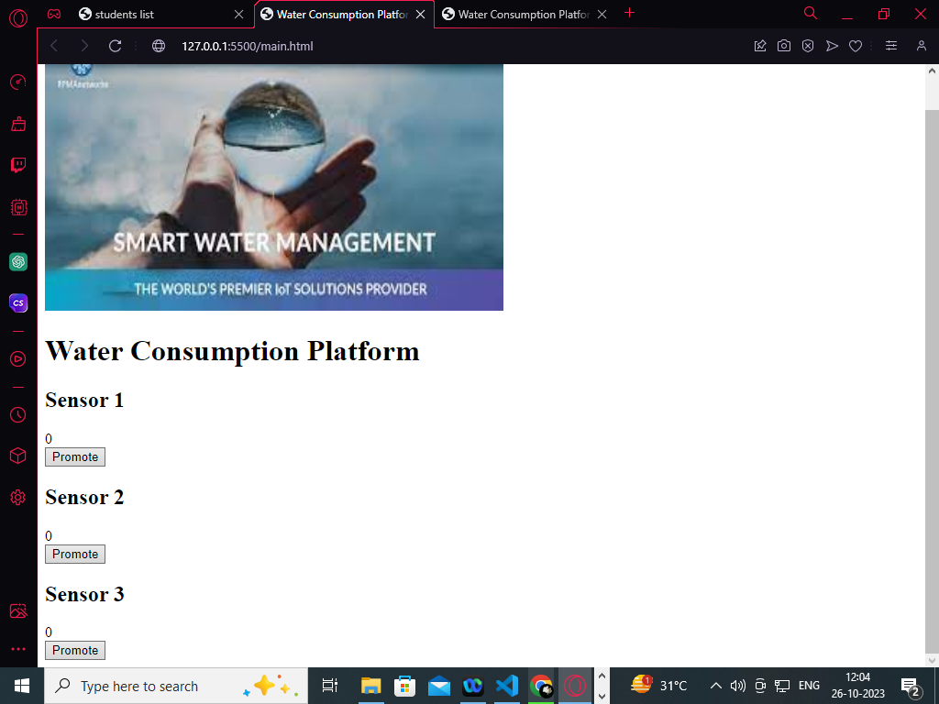

**Pattern:**

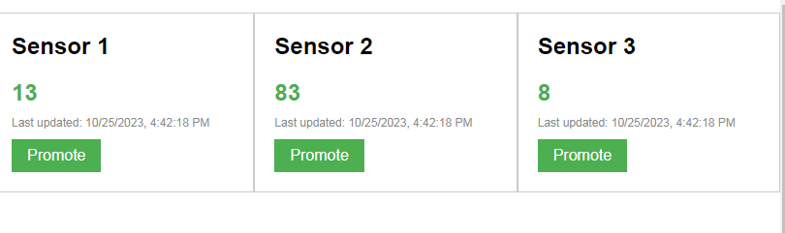

**CODE:**

**//html code**

<!DOCTYPE html>  
<html>  
<head>  
    <title>Water Consumption Platform</title>  
     
</head>  
<body>  
    <h1>Water Consumption Platform</h1>  
    <div id="dataContainer">  
        <div class="sensorCard">  
            <h2>Sensor 1</h2>  
            <div class="sensorValue" id="sensor1Value">0</div>  
            <div class="lastUpdated" id="sensor1LastUpdated"></div>  
            <button class="promoteButton" onclick="promoteWaterConservation(1)">Promote</button>  
        </div>  
        <div class="sensorCard">  
            <h2>Sensor 2</h2>  
            <div class="sensorValue" id="sensor2Value">0</div>  
            <div class="lastUpdated" id="sensor2LastUpdated"></div>  
            <button class="promoteButton" onclick="promoteWaterConservation(2)">Promote</button>  
        </div>  
        <div class="sensorCard">  
            <h2>Sensor 3</h2>  
            <div class="sensorValue" id="sensor3Value">0</div>  
            <div class="lastUpdated" id="sensor3LastUpdated"></div>  
            <button class="promoteButton" onclick="promoteWaterConservation(3)">Promote</button>  
        </div>  
    </div>  
  
     
</body>  
</html>

**//css code:**

  body {  
            font-family: Arial, sans-serif;  
        }  
  
        h1 {  
            text-align: center;  
            margin-top: 40px;  
        }  
  
        #dataContainer {  
            display: flex;  
            justify-content: space-between;  
        }  
  
        .sensorCard {  
            width: 300px;  
            border: 1px solid #ccc;  
            padding: 20px;  
            margin-bottom: 20px;  
        }  
  
        h2 {  
            margin-top: 0;  
        }  
  
        .sensorValue {  
            font-size: 24px;  
            font-weight: bold;  
            color: #4CAF50;  
            margin-bottom: 10px;  
        }  
  
        .lastUpdated {  
            font-size: 12px;  
            color: #888;  
        }  
  
        .promoteButton {  
            background-color: #4CAF50;  
            color: white;  
            border: none;  
            padding: 8px 16px;  
            text-align: center;  
            text-decoration: none;  
            display: inline-block;  
            font-size: 16px;  
            margin-top: 10px;  
            cursor: pointer;  
        }

**//javascript code:**

  function updateSensorValue(sensorId) {  
            var sensorValue = Math.floor(Math.random() * 100); // Replace with actual sensor data  
  
            var valueElement = document.getElementById("sensor" + sensorId + "Value");  
            var lastUpdatedElement = document.getElementById("sensor" + sensorId + "LastUpdated");  
  
            valueElement.textContent = sensorValue;  
            lastUpdatedElement.textContent = "Last updated: " + new Date().toLocaleString();  
        }  
  
        function promoteWaterConservation(sensorId) {  
            // Code to promote water conservation efforts  
            alert("Promote water conservation for sensor " + sensorId);  
        }  
  
        setInterval(function() {  
            // Update sensor values every 5 seconds  
            updateSensorValue(1);  
            updateSensorValue(2);  
            updateSensorValue(3);  
        }, 5000);

**RASPBERRY PI INTEGRATION:**

python

import RPi.GPIO as GPIO

import time

# Set up GPIO pins for sensors and actuators

water_level_pin = 17

valve_pin = 18

GPIO.setmode(GPIO.BCM)

GPIO.setup(water_level_pin, GPIO.IN)

GPIO.setup(valve_pin, GPIO.OUT)

# Function to check water level

def check_water_level():

if GPIO.input(water_level_pin):

return "Low"

else:

return "High"

# Function to control the valve

def control_valve(state):

GPIO.output(valve_pin, state)

# Main loop

while True:

water_level = check_water_level()

print("Water level:", water_level)

if water_level == "Low":

control_valve(GPIO.HIGH) # Turn on the valve

print("Valve opened")

else:

control_valve(GPIO.LOW) # Turn off the valve

print("Valve closed")

time.sleep(5) # Wait for 5 seconds before checking again

# Clean up GPIO pins

GPIO.cleanup()

SCHEMETIC DIAGRAM:

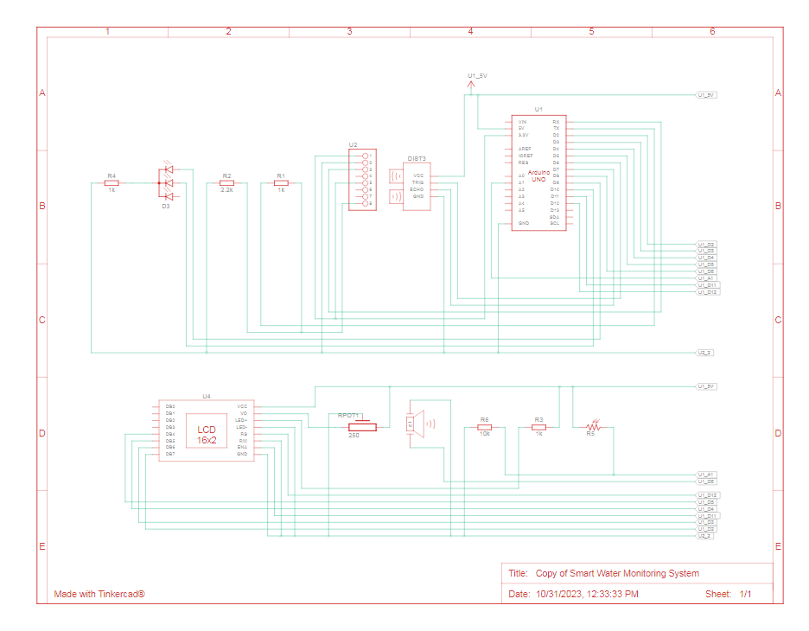

**MOBILE APP DEVELOPEMENT (screenshots)**

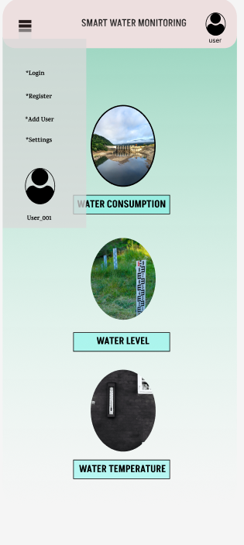

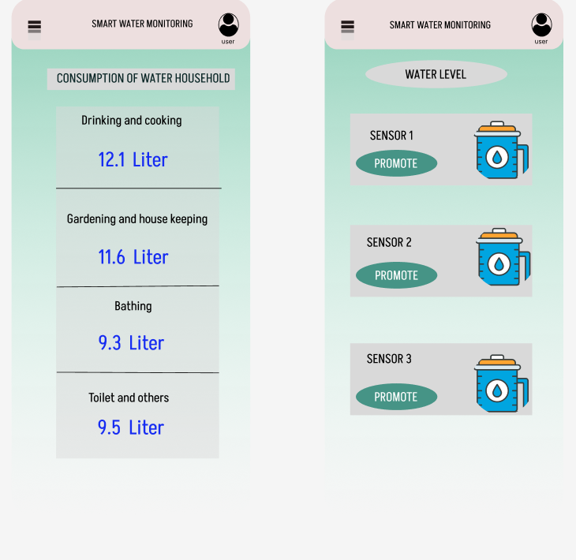

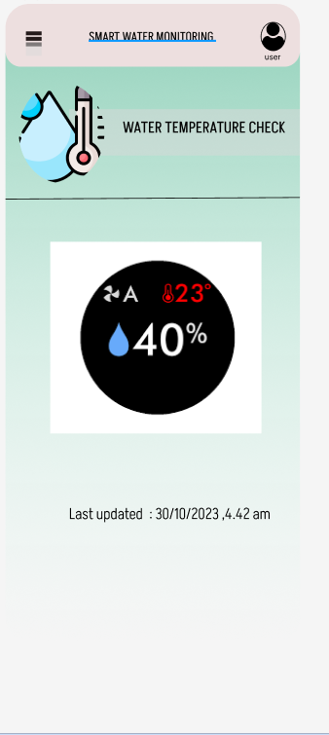

**The real-time water consumption monitoring system can promote water conservation and sustainable practices:**

🡪Reducing waste of water-intensive industries

### 🡪Monitoring water quality to fight pollution and diseases

### 🡪Improving the efficiency of water systems

### 🡪Creating awareness of household water use thanks to smart meters

🡪Providing running water through innovative solutions all around the world